**DAILY ONLINE ACTIVITIES SUMMARY**

|  |  |  |  |  |  |  |  |  |
| --- | --- | --- | --- | --- | --- | --- | --- | --- |
| **Date:** | **26-05-2020** | | | | | **Name:** | **Raksha S** | |
| **Sem & Sec** | **6th B** | | | | | **USN:** | **4AL17CS073** | |
| **Online Test Summary** | | | | | | | | |
| **Subject** | | **CGV** | | | | | | |
| **Max. Marks** | | **30** | | **Score** | | | **21** | |
| **Certification Course Summary** | | | | | | | | |
| **Course** | **Cyber security specialisation**  **Ethical hacking** | | | | | | | |
| **Certificate Provider** | | | **Udemy**  **greatlearning** | | **Duration** | | | **18.5**  **10** |
| **Coding Challenges** | | | | | | | | |
| Problem Statement: 1. Write a program in C to print all permutations of a given string using pointers  2. Given an array A of size N where the array elements contain values from 1 to N with duplicates, the task is to find total number of subarrays which start and end with the same element. | | | | | | | | |
| **Status:** YES, Completed all Programs | | | | | | | | |
| **Uploaded the report in Github** | | | | | **YES** | | | |
| **If yes Repository name** | | | | | https://github.com/raksha05/Daily-Status/Raksha-4AL17CS073/Raksha | | | |
| **Uploaded the report in slack** | | | | | **YES** | | | |

Online Test Details:

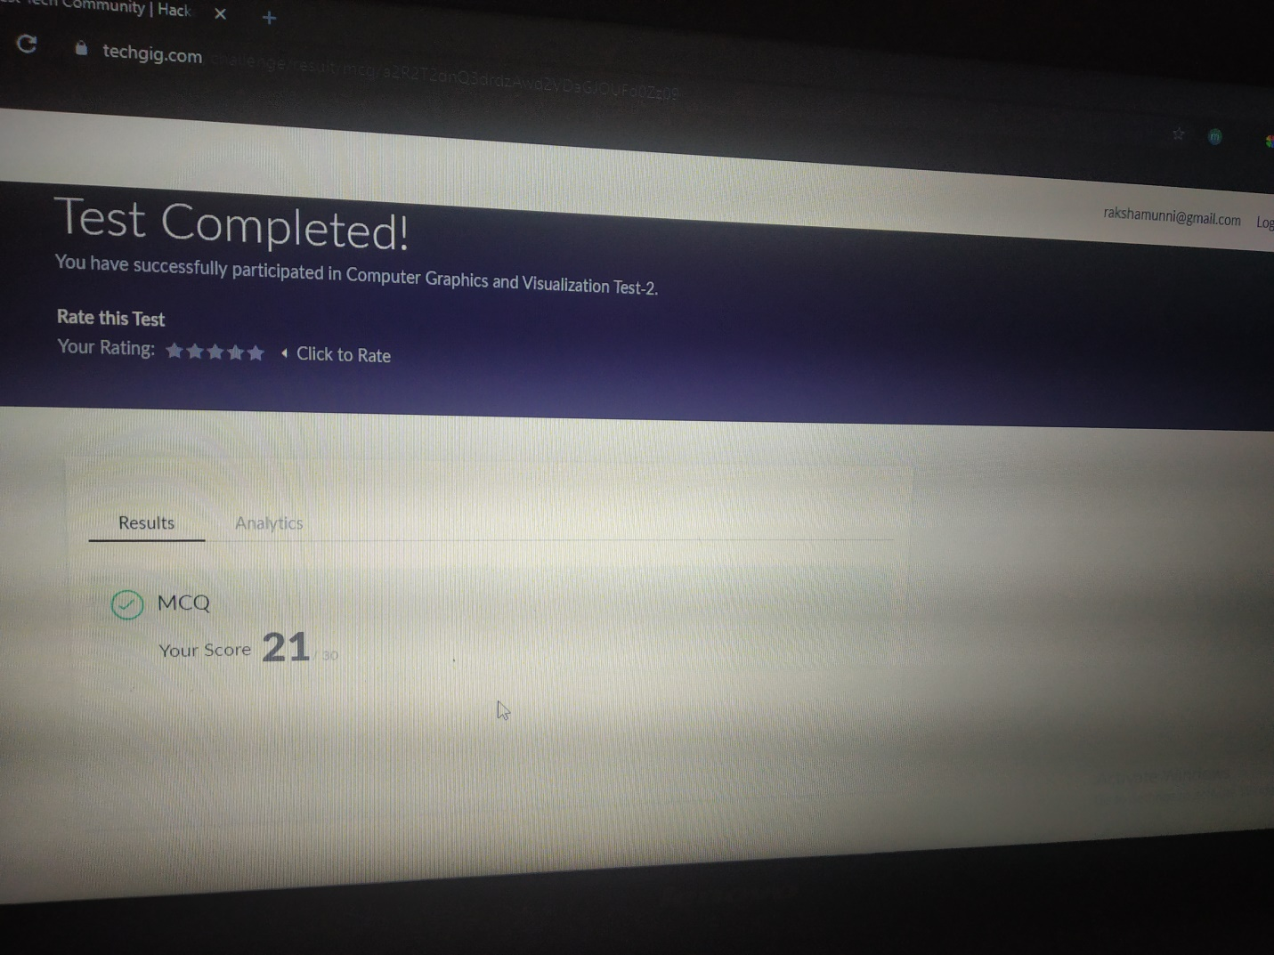

Scored 21 out of 30 in CGV 2nd I.A test

Certification Course Details:

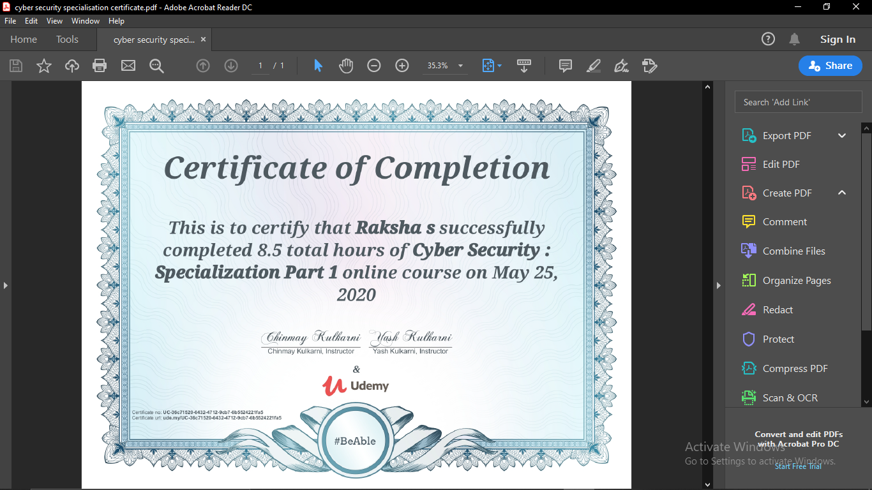

The above course is being taken up by me is based on cyber security.The details of the course and certificate provider are mentioned in the above form.Successfully completed the course.

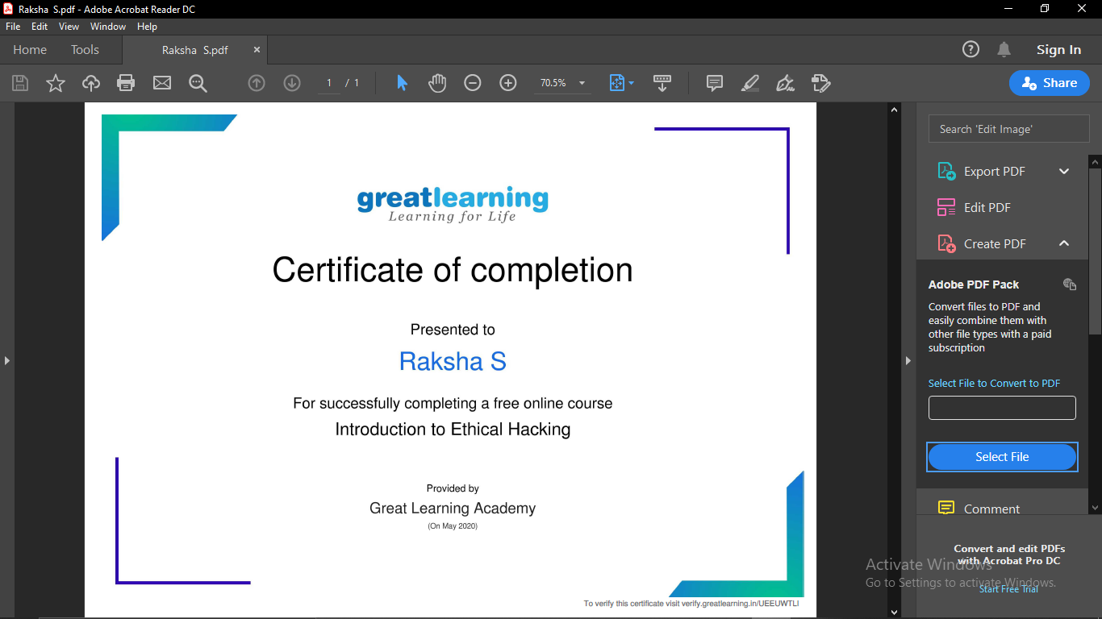

Coding Challenges Details:

Program1:

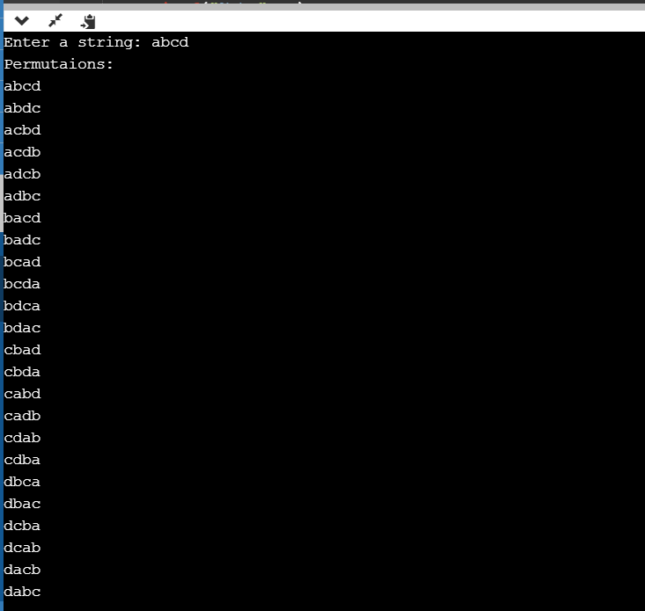

Program2:

